**BayCare Health System & Pharmogistics**

**RDS/RDE Interfaces**

**2.0**

**Prepared By: Tony McArtor & Stephen Mattei SM 1.0**

**Date: 07/30/19**

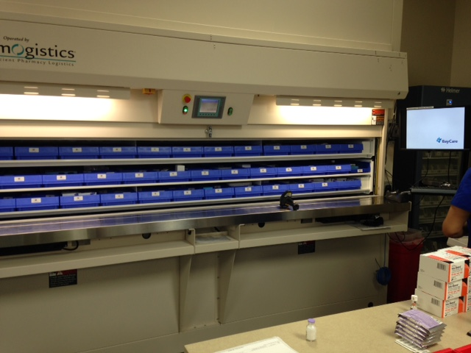

Photo of the carousel at SJS with about 1500 meds stocked.

Document Control 3

Resources 3

Project Distribution List 3

Document Version Control 3

1. Introduction 4

1.1 Purpose 4

1.2 Project Scope 4

1.4 Terminology Standards 4

1.4.1 Acronyms 4

1.4.2 Glossary 4

1.5 Document References 4

2.0 Diagram 5

3. Requirements 6

3.1.1 Functional Requirements (Cloverleaf) 6

3.1.2 Functional Requirements (Cerner) 6

3.1.3 Non-Functional Requirements (Cloverleaf) 6

3.1.4 Non-Functional Requirements (Cerner) 7

3.2 Messaging Protocols 7

3.2.1 Inbound to the BayCare Cloverleaf –N/A 7

3.2.2 Outbound from the BayCare Cloverleaf for (RDS) RDE’s 7

3.2.5 Inbound from BayCare Cerner to Cloverleaf for (RDS) RDE’s 7

3.2.6 Outbound from BayCare Cerner –N/A 7

4. HL7 Messaging 8

4.1 Messaging Format 8

4.1.1 Segments 8

4.1*.2* Messaging Event Types 8

4.2 Data Transformation Requirements 9

4.3 Sample Message 9

5. Testing 10

5.1. Unit Testing Scenarios 10

5.2 Integrated Testing Scenarios 10

5.3 Testing Approvals 10

5.3 Piloting 10

5.5 Approvals 10

6. Deployment / Implementation Model 11

Appendix A: Risks and Concerns 11

Appendix B: Issues List 11

# **Document Control**

## Resources

|  |  |  |
| --- | --- | --- |
| **Name** | **Role** | **Email** |
| Kelly Arestia | BayCare Project Manager | [Kelly.Arestia@baycare.org](mailto:Kelly.Arestia@baycare.org) |
| Tony McArtor | BayCare Integration Analyst | [Tony.McArtor@baycare.org](mailto:Tony.McArtor@baycare.org) |
| Stephen Mattie | BayCare Integration Analyst | Stephen.Mattei@baycare.org |
| Charles De La torre | PHARMACY SYSTEMS COORD - EMR | Charles.DeLatorre@baycare.org |
| Pete Konidas | CLINICAL PHARMACIST | Pete.Konidas@baycare.org |
| Ira Kurland | CLINICAL PHARMACIST | Ira.Kurland@baycare.org |
| Steve Carpenter | SYSTEMS ANALYST SR | Steve.Carpenter@baycare.org |
|  |  |  |
|  |  |  |

## Project Distribution List

## Document Version Control

|  |  |  |  |
| --- | --- | --- | --- |
| **Version** | **Date** | **Modifier** | **Description** |
| V1.0 | 07/09/2015 | Tony McArtor | Originally Created |
| V1.1 | 08/08/2015 | Tony McArtor | Update |
| V1.2 | 06/07/2016 | Tony McArtor | Update FR.2015.07.4 |
| V2.0 | 7/30/2019 | Art Schwartz | Updated for Cerner Model |

# 1. Introduction

## 1.1 Purpose

This document describes implemented requirements for a HL7 interface between BayCare healthcare information systems and CareFusion (Pharmogistics) systems. The document specifies the implemented BayCare HL7 message format for communicating with CareFusion (Pharmogistics) systems.

## 1.2 Project Scope

The CareFusion (Pharmogistics) application uses these transactions to track inventory as it is distributed to the CareFusion stations throughout the institution.

## 1.4 Terminology Standards

### 1.4.1 Acronyms

MLLP – Minimum Lower Layer Protocol for messaging framing a HL7 message.

### 1.4.2 Glossary

## 1.5 Document References

List all documents or Web addresses to which this IDBB refers; provide enough information so that the reader can access a copy of each reference. Include the title, author, version number, date, and source or location.

**Cerner Specifications:** No official Cerner Specification released

**Pharmogistics Specifications** 10000224753-04 Pyxis Pharmogistics HL7 Msg Spec Guide.pdf

## 2.0 Diagram

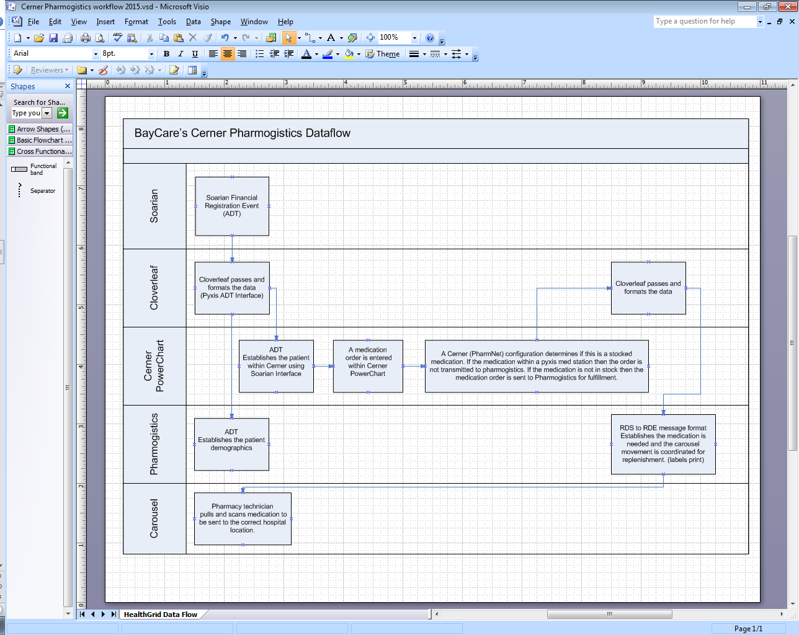

# 3. Requirements

## 3.1.1 Functional Requirements (Cloverleaf)

|  |  |  |
| --- | --- | --- |
| **Cloverleaf** |  |  |
| **Number** | **Requirement Name** | **Requirement Description** |
| FR.2015.07.1 | Remove ZX3 Segment | Vendor does not accept this segment and has requested that it be removed |
| FR.2015.07.2 | PID:5.0 Filter | Filter messages with BAYCARE in PID:5 (retained from Talyst configuration) |
| FR.2015.07.3  FR.2019.07.30 | ZX3:1 | Filter compound IV types using a fixed table (retained from Talyst configuration) |
|  | Add Segment filter  Change data proc | Discard AL1 OBX and RXO segments  Blank out RXC 2.5 |

## 3.1.2 Functional Requirements (Cerner)

|  |  |  |
| --- | --- | --- |
| **Cerner** |  |  |
| **Number** | **Requirement Name** | **Requirement Description** |
| FR.2015.07.4  FR.2015.07.5  FR.2015.07.6  FR.2015.07.7  FR.2015.07.8  FR.2015.07.9  FR.2015.07.10  FR.2016.04.08 | Facility Filter  Fill List Filter  CUSTOM Z SEGMENT  Message Type Change  Filter by dispense location  Filter charge quantity  Provider cleanup script  Filter by dispense location | This interface filters on the facility code relating to the production sites. Currently, BayCare is only sending all sites orders.  This filter stops the orders that are batched out of Cerner.  This segment is built for additional filtering within Cloverleaf  Trigger needs to be RDS but message header is changed to RDE  If order processing doesn’t use "XX Inventory Manager" then order is skipped. This is done to keep pharmogistics and pxyis med stations workflow correct.  If charge quantity equals “0” then delete message  Script cleans up Cerner’s OB provider processing  We are changing the look up from one table to another from (DISPENSE_FROM_S) to (CUR_DISP_LOC_S). |
|  |  |  |

## 3.1.3 Non-Functional Requirements (Cloverleaf)

|  |  |  |
| --- | --- | --- |
| **Cloverleaf** |  |  |
| **Number** | **Requirement Name** | **Requirement Description** |
|  |  |  |
|  |  |  |

## 3.1.4 Non-Functional Requirements (Cerner)

|  |  |  |
| --- | --- | --- |
| **Cerner** |  |  |
| **Number** | **Requirement Name** | **Requirement Description** |
|  |  |  |

## 3.2 Messaging Protocols

Below are listed the details for the messaging protocols that will be leveraged for this integration. Please see the reference document located on the Integration SharePoint server: <insert link to document here>

### 3.2.1 Inbound to the BayCare Cloverleaf –N/A

### 3.2.2 Outbound from the BayCare Cloverleaf for (RDS) RDE’s

**Test**

Port Number: 8006

IP Address: 10.44.110.83

**Prod**

Port Number: 8008

IP Address: 10.44.110.113

### 3.2.5 Inbound from BayCare Cerner to Cloverleaf for (RDS) RDE’s

**Cert Test**

Port Number: 22088

IP Address: 10.100.128.66

**Mock Test**

Port Number: 22090

IP Address: 10.100.128.66

**Prod**

Port Number: 22088

IP Address: 10.100.128.64

### 3.2.6 Outbound from BayCare Cerner –N/A

# 4. HL7 Messaging

## 4.1 Messaging Format

Cerner triggers this message as a RDS then converts the message to a RDE event type. This is because within Cerner there is a difference in the workflow between these two message triggers. An RDE triggered event will create two order messages one when the nurse orders the mediation and a second when the pharmacy adjusts the order. An RDS triggered message only transmits the pharmacy approved message. BayCare changed from the RDE to the RDS because pharmogistics system was unable to handle the modify order and this process created duplicates.

### 4.1.1 Segments

The segments utilized for this interfaces are:

MSH PID ORC RXE RXR ZXE ZRC

### 4.1*.2* Messaging Event Types

Below are the messages types necessary for this integration

|  |  |
| --- | --- |
| **Event Type** | **Description** |
| RDE^O01 | Pharmacy/treatment encoded order message |
| RDS^O01 | Pharmacy/treatment encoded order message |

## 

## 4.2 Data Transformation Requirements

|  |  |  |  |  |  |
| --- | --- | --- | --- | --- | --- |
| **Field Description** | **HL7 Field Loc.** | **Required Y/N** | **Data Type** | **Length** | **Notes** |
| MSH Segment | MSH | Y |  |  | Pathcopy Segment |
| Encoding characters | MSH-2 | Y |  |  | Hard code - =^~\& |
| Sending application | MSH-3 | Y |  |  | Hard code HNAM |
| Sending Facility | MSH-4 | Y |  |  | Copy PV1-3.3 |
| Receiving Application | MSH-5 | Y |  |  | Hard Code PYXISRX |
| Receiving Facility | MSH-6 | Y |  |  | Copy PV1-3.3 |
| Version ID | MSH-12 | Y |  |  | Hard code 2.3 |
| PID Segment | PID | Y |  |  | Pathcopy |
| Patient ID external | PID-2 | Y |  |  | Null out |
| Patient ID internal | PID-3 | Y |  |  | Copy MRN from PID-2 |
| Alternate patient ID | PID-4 | Y |  |  | Null out |
| Patient Account Number | PID-18 | Y |  |  | Null out 4th,5th and 6th sub fields |
| Phone number home | PID-13 | Y |  |  | Null out 1st and 2nd sub fields |
| PV1 segment | PV1 | Y |  |  | Pathcopy Segment |
| Visit Number | PV1-19 | Y |  |  | Null out 1st 6 sub fields |
| Servicing Facility | PV1-39 | Y |  |  | Null out |
| ORC Segment | ORC | Y |  |  | Pathcopy Segment |
| Filler Order Number | ORC-3 | Y |  |  | Copy ORC-2 |
| Ordering provider | ORC-12 | Y |  |  | Null out |
| Quantity Timing | ORC-7 | Y |  |  | If the 6th sub field is STAT  Hard code 2 to 7th sub-field  Null out 6th sub field  If the 2nd sub filed is Y  Null out second sub field  Copy 2nd sub filed to 8th sub field |
| RXR segment | RXR | Y |  |  | Pathcopy |
| NTE segment | NTE | Y |  |  | Pathcopy |
| RXC segment | RXC | Y |  |  | Pathcopy - Except  Pyxis does not want RXC segments with Premix Diluents |
| Component type | RXC-1 | Y |  |  | Copying an A to RXC:1 because Pyxis must have a value even if it is not applicable in RXC:1. This value displays to end user as additive even though the data passed is not an additive. |
| CUSTOM ZRC SEGMENT | ZRC | Y |  |  | Date and time adjustments |
| RXE dispense amount | RXE 10 | Y |  |  | dispense amount = charge quantity |

## 4.3 Sample Message

MSH|^~\&|HNAM|CERNER|PYXISRX|PYXIS|20150622134349||RDE|Q1918831452T22031190|P|2.3||||||8859/1

PID|1||2104700392||SJSPYXISES^TESTONE^^^^^Current||19400501|M||B|1200 7TH AVE S^^Saint Petersburg^FL^33702^^Home||||English|X|CD:738196081|1100099055||||NOH|||0

PV1|1|I|A3EA^3207^A^SJS^^Bed(s)^SJS|R||||||MED||||CD:||Yes||I||8|||||||||||||||||||||Active|||20150506091500

ORC|NW|4406197337^HNAM_ORDERID|163762392^HNAM_DISPENSEID|163762391^HNAM_RUNID|Or||^q12hr&0900,2100^^20150622210000^^^^fluticasone nasal 50 mcg / 1 spray(s) Spray Nasal q12hr||20150622134349||PJK89237^Bkgsitz^Vyjy^Q^^^^^External Id^Personnel^^^External Identifier|||||CD:2346^Initial Doses

RXE|^q12hr&0900,2100^^20150622210000^^^^fluticasone nasal 50 mcg / 1 spray(s) Spray Nasal q12hr|2341505^fluticasone 0.05 mg/inh Nasal Spray^Pyxis Interface ID|1||EA^EA^^^50 mcg / 1 spray(s)|Spray^Spray|For intranasal use|||1|EA^EA|||PJK89237^Bkgsitz^Vyjy^Q^^^^^External Id^Personnel^^^External|4406197337|||20150622134349

RXR|Nasal^Nasal|||MED

# **5. Testing**

## 5.1. Unit Testing Scenarios

|  |  |
| --- | --- |
| **Scenario** | **Expected Result** |
| Testing was completed by project team | Passed |

## 5.2 Integrated Testing Scenarios

|  |  |
| --- | --- |
| **Scenario** | **Expected Result** |
| Testing was completed by project team | Passed |

## 5.3 Testing Approvals

|  |  |  |  |
| --- | --- | --- | --- |
| **Testing Phase** | **Date** | **Department** | **Team Member** |
| PH1.UNIT | 07/01/2015 | Pharmacy | Pete Konidas |
| PH1.INTEGRATED | 07/01/2015 | Pharmacy | Charles De La torre |

### 

## 5.3 Piloting

This interface was initially deployed for pharmogistics at SJS.

## 5.5 Approvals

|  |  |  |  |
| --- | --- | --- | --- |
| **Testing Phase** | **Date** | **Department** | **Team Member** |
| PH1.0 | 07/01/2015 | PMO | Kelly Arestia |
|  |  |  |  |
| PH2 | 3/10/2016 | Pharmacy | C De La Torre & P Konidas |

# 6. Deployment / Implementation Model

The pharmogistics (cloverleaf) interface is facility agnostic; however, Cerner interface script will need to update the default pharmacy locations as they are defined.  All Sites are on the pharmogistics application at this time.

Appendix A: Risks and Concerns

|  |  |  |  |  |  |  |  |  |
| --- | --- | --- | --- | --- | --- | --- | --- | --- |
| **<Project Name>** |  |  | | |  |  |  |  |
| **Number** | **Risk / Concern** | **Comment** | **Mitigation** | | |  |  |  |
| RC.2015.7.22 | Some Order maybe incorrectly filtered | This e-mail is about the RDE (changing to RDS) pharmogistics interface and Cerner’s system performance.  It has been seen during testing that if Cerner’s environment is slow the pharmogistic’s interface filter can be affected. This is because we have two database lookups that are being used for workflow filtering.  These filters are pulling from dispense category location and charge quantity. Also, these fields are completed later during the order entry process. It has been observed that if Cerner’s environment is running slow the tables (FDC.DISPENCE) from the UI entry are not updated before the FSI order trigger has fired. This causes an order or medication to be missing from the pharmogistics application. Currently, I have not found this to be an issue in production. | | |  |  | | --- | --- | | **Not an issue in production** |  | | |  |  |  |

# Appendix B: Issues List

<This is a dynamic list of the open issues related to the IDBB that remain to be solved, including but not limited to TBDs, pending decisions, information needed, conflict awaiting resolution, and the like.>

|  |  |  |  |  |  |  |  |  |  |
| --- | --- | --- | --- | --- | --- | --- | --- | --- | --- |
| **<Project Name>** |  | |  | | |  |  |  |  |
| **Number** | **Issue** | | **Comment** | **Fix** | | |  |  |  |
| I.2013.1.0 |  |  | | |  | |  |  |  |

* End of document